Benha University  Faculty of Engineering at Shoubra  Energy Engineering Dep. |  | Mid Term Exam (Fall 2018)  Date: Monday (19/3/2018)  Subject: Electronic Engineering  Duration: 1 hour
- Answer all the following questions |  | - No. of questions : 2  - Total Mark: 30 Marks
Question (1) (15 Marks)
- Give one application for: (Diode, Zener diode, LED) (3 marks)

- The ideal diode acts as...…........ In forward connection and acts as …….....….. For reverse. (2 marks)
- Practical diode acts as...…........ In forward connection and acts as …….....….. For reverse. (2 marks)
- Silicon diode need …..V to operate while Germanium diode require ………V to operate. (2 marks)
- What diode is similar to zener diode when it connected in forward? (1 marks)
- Zener diode 5V, mean that it is battery of ……. In forward and battery of ……. In reverse. (2 marks)
- Sketch the block diagram of a 5v power supply and show the waveform after each block. (3 marks)

Question (2) (15 Marks)
- Determine and sketch the peak value of the output voltage and PIV for the circuit in Fig. 1.
- Calculate the current through 48 Ω in the circuit shown in the Figure (2). Assume all diodes to be ideal.
- A zener diode used as a regulator at 6.2V, connected in shunt regulation with unknown R_{L}. If the DC input was 5V and the Rs= 10 Ω, calculate the value of the R_{L} that makes the power dissipated through the Rs be 1W.
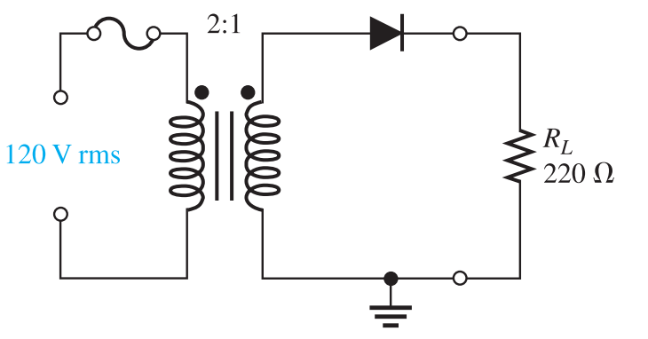 | 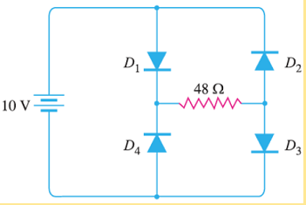
Fig. 1 | Fig. 2

